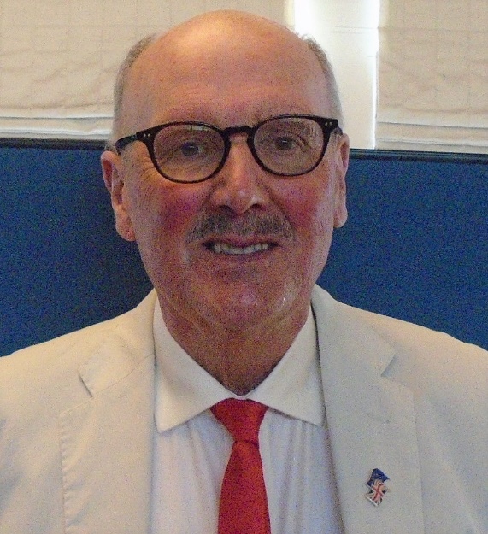
David Taylor-Gooby Candidate for Secretary 2019

Dear Colleagues

I wish to put myself forward for the position of Secretary for the next year.

As most of you know I have served as Secretary for several years. I am not claiming to have been perfect, but I did manage to keep the Association going in the North East and during that time I feel our influence and prominence in the Labour Movement has grown. I must acknowledge the help and support I have received from other officers and members, particularly Rita Stringfellow, Brian Flood, Paul Leake, Diane Jones,Pam Wortley and Lewis Atkinson.

My aim has been to campaign for a publicly funded health service and also to highlight particular areas of concern such as the crisis in social care, the drastic cuts to public health and issues of democratic governance in the NHS. As well as politicians I have sought to ask health professionals to give us an inside view of the challenges facing these services.

During my period of office we have established close relations with Grahame Morris M.P., Paul Williams M.P. and Sharon Hodgson M.P. We have also worked closely with officers and members from various local authorities particularly Newcastle, South Tyneside and Durham.

My background of almost 50 years in the Labour Party where I have served as a councillor, Chair of a social housing company and more recently as a member of a CCG has given me wide experience and enabled me to make contacts throughout the Region. I am now a co-opted member of Durham County Council Health and Social Care OSC.

This is a crucial time with the possibility of a General Election ever with us and I would like to continue to promote our influence in the Region and help shape policies for the next Labour Government.

I hope you will give me your continued support.

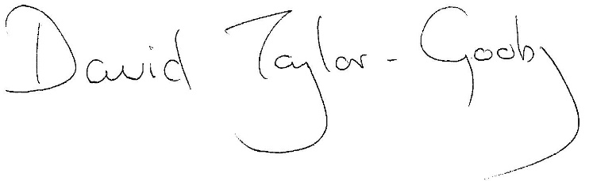
David Taylor-Gooby

